

**Building an online sneaker sales system**

**Final Release Document**

–Danang , Jul 203 –

**Table of Contents**

**I. Deliverable Package** **3**

**II. Installation Guides** **3**

**III. User Manual** **6**

1. Overview 6

2. Account Registration 6

3. Log in 7

4. Log out 8

5. Change password 8

6. Forgot password 9

7. View products 10

8. Search products 10

9. Read contents 11

10. View personal information 12

11. Update personal information 13

12. Purchase 15

13. Choose a payment method 18

14. CRUD items in cart 19

15. View purchase history 24

16. Track Order 25

17. View contact information 26

18. Chat with the shop 27

19.CRUD Content 29

20. Confirm order: 32

21. View order details 35

22. Confirm delivery 35

23. Check failed delivery 36

24. CRUD products 37

25. View order status 39

26. View sale history 40

27. View the revenue 40

28. View detailed order history 41

29. CRUD employees 41

# I. Deliverable Package

| **No** | **File** | **Notes** |
| --- | --- | --- |
| 1 | Group5_HS_DB_final.sql | Database, including both table structures and table data |
| 2 | SE17A08_Group 5_SRS_Final.docx | Final SRS (Requirement) Document |
| 3 | SE17A08_Group 5_SDS_ Final.docx | Final SDS (Design) Document |
| 4 | SE17A08_Group 5_Project Tracking.xlsx | Final status for the application functions, which include:  - Function name, feature, roles, function description (changes compared to the original requirements are highlighted)  - In Charge, Planned iteration & Actual iteration  - Final status & note on the update you made  - The links to the SRS & SDS are tracked |
| 5 | SE17A08_Group 5_Issues Report.xlsx | Final issues tracking list of the whole project |

Other related deliverables:

* Tagged source codes: [HIPSTERSHOP -GITHUB LINK](https://github.com/tammv/hipster_sneaker_shop)
* Demonstration video: [Video demo](https://drive.google.com/file/d/10xZ2P6twWghWQ18MjuOwh_Weq6hRFu7K/view?usp=sharing)

# II. Installation Guides

* Step 1: Visit the GitHub page to download the project's source code:

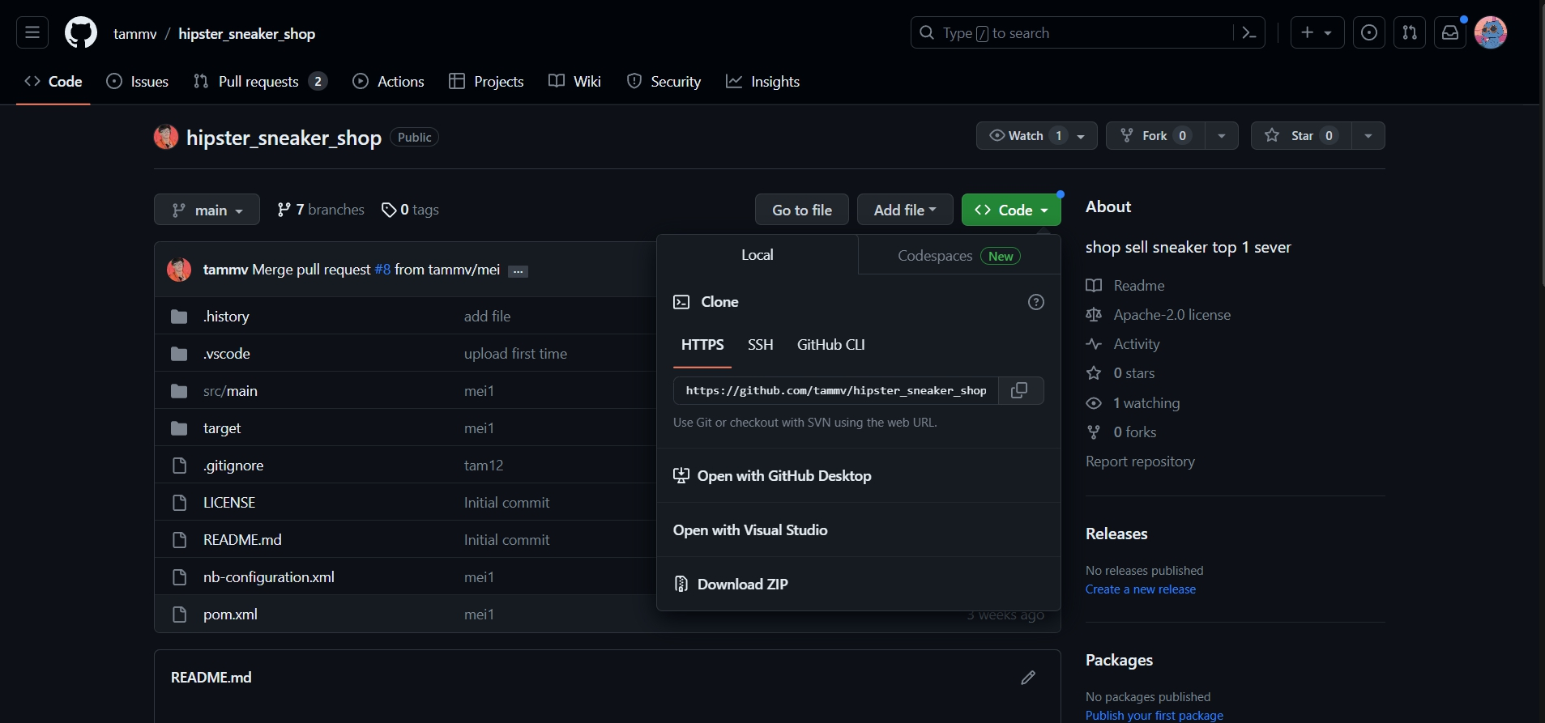

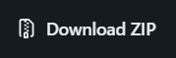

* Step 2: Click on icon to download the source code zip file to your device:



* Step 3: Open the Netbean app and open the downloaded project:

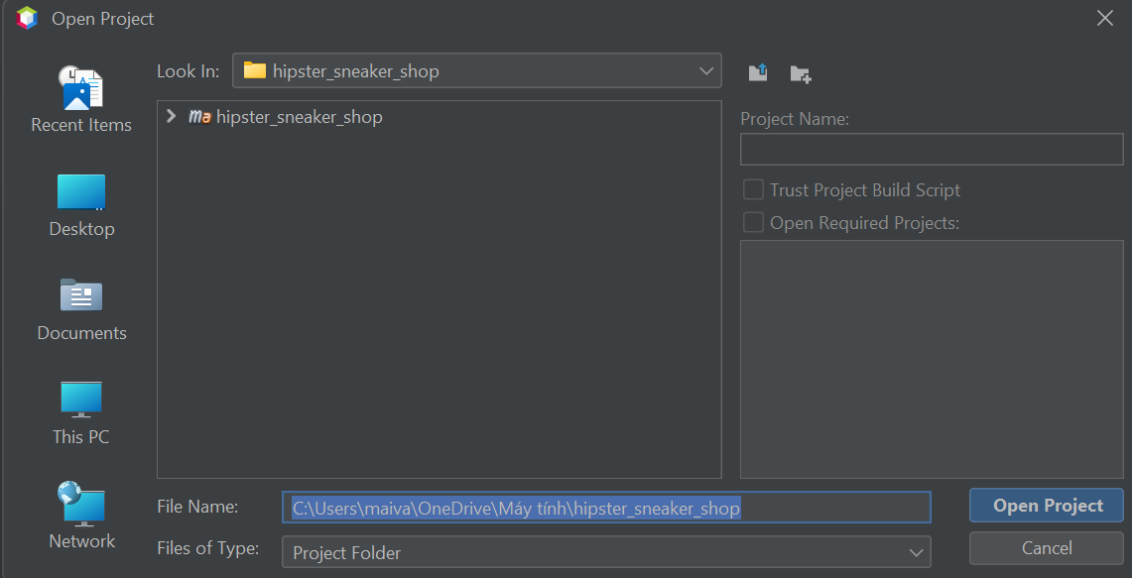



* Step 4: Right click on the project and select button to run the project

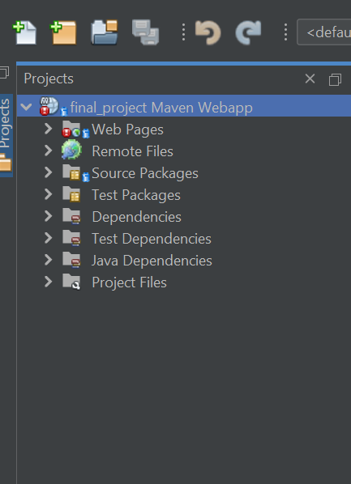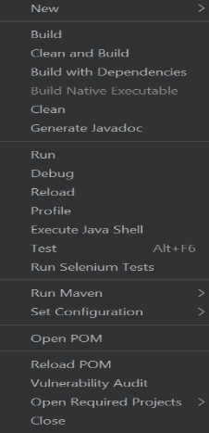

* Step 5: Run the project on tomcat server:

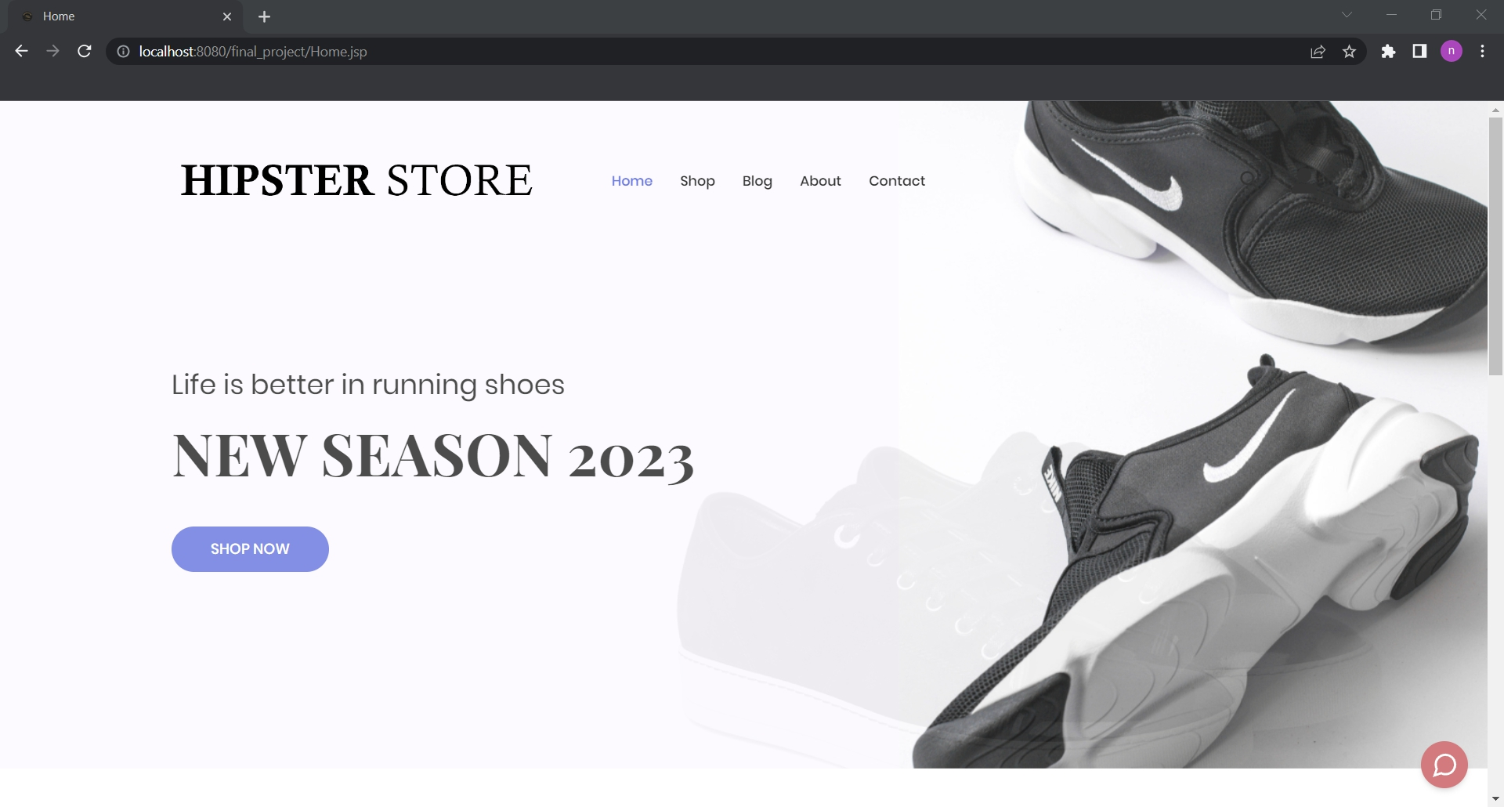

# III. User Manual

[In this part, you provide overall descriptions of the application, the briefs of the application’s workflows and the details guide of each workflow that the end user can use]

## 1. Overview

The user guide presented here is for the "Hipster Store," an online sneaker sales system, that provides comprehensive instructions on its usage. The system provides various functionalities for users, including account registration, login, product viewing and searching, content reading, purchasing, payment selection, cart management, purchase history viewing, order tracking, contact information access, shop chat, content management, product management, and more.

Guest: Users who have not logged into their account on the shoe store website. Guests can view product listings and descriptions but cannot engage in shopping activities or manage their personal accounts.

Customer: Users who have registered an account on the shoe store website and can engage in shopping activities and manage their accounts.

Shipper: Individuals responsible for delivering orders from the shop to the customer's shipping address. They can update the delivery status of orders. Their accounts are authorised by Store Administrators.

Content Creator: Individuals responsible for creating advertising content for products, including images and product descriptions. Their task is to attract customers to the products and help increase sales. Their accounts are authorised by Store Administrators.

Seller: Individuals responsible for providing detailed product information, managing orders, managing discount programs, and managing income. Their accounts are authorised by Store Administrators.

Store Administrators: Individuals who manage and operate the shoe store website. They have similar functions as sellers but also have the ability to grant permissions to other staff accounts.

The user manual section of this document provides an overview of the application, the workflow summaries, and detailed guides for each workflow, enabling end users to understand and effectively utilise the various functions of the Hipster Store website.

## 2. Account Registration

This is a function to help people who do not have an account create an account on the system

Step 1: Click on the icon in the right corner of the screen

Step 2: select the option Sign up

Step 3: Choose button Sign Up

Step 4.1: Enter the information fields in the correct format

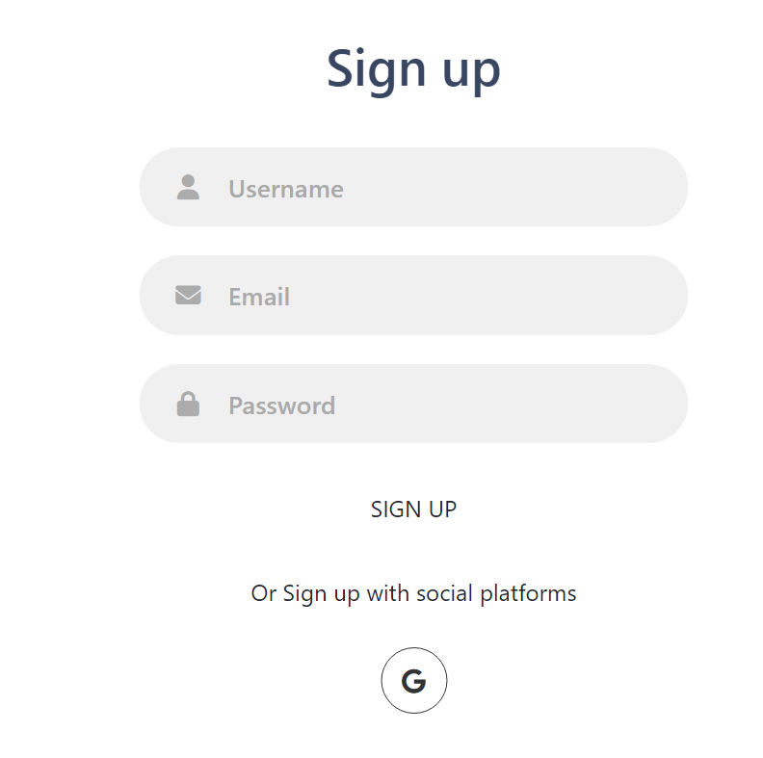

Step 4.2: Sign in with Gmail by clicking on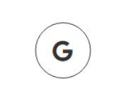

Step 5: Enter the confirmation code on the email confirmation page

## 3. Log in

the function for you to log in to an account already registered and existing in the system

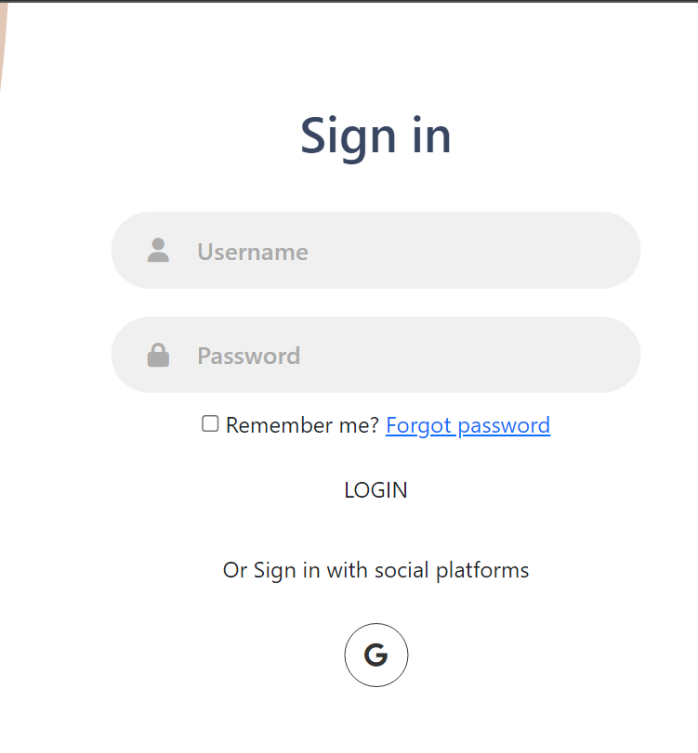

Step 1: Click on the icon in the right corner of the screen

Step 2: select the option Login

Step 3: Choose button Log in

Step4.1: Enter the information fields in the correct format

Step 4.2:Sign in with gmail by clicking 

Step 5 :Enter the confirmation code on the email confirmation page

## 4. Log out

The function is only available when you have successfully logged into the system

Step 1: Click on the icon in the right corner of the screen

Step 2: select the option Log out

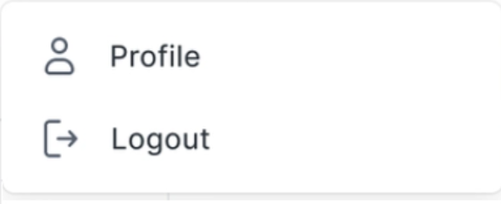

## 5. Change password

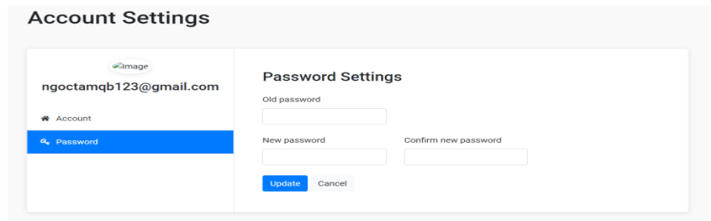

Step 1: Click on the icon in the right corner of the screen

Step 2: select the option 

Step3 : Click option Password

Step 4: Input the old password, New password , Confirm new pass word

Step 5: Click 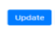

## 6. Forgot password

Step 1: At the login page choose forgot password option

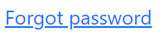

step 2 : enter the email or user name the account forgot password

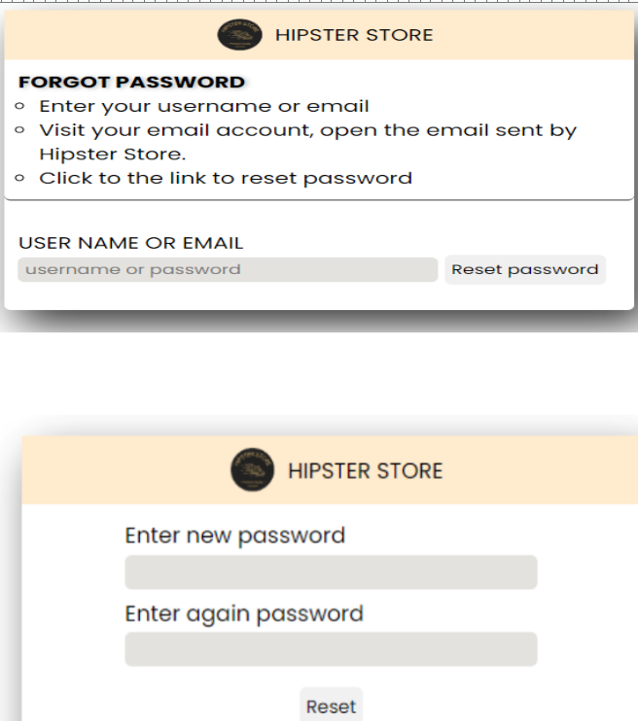

Step 3 : Check mail and click to the link reset password

Step 4: Enter the new password

Step 5: click button RESET

## 7. View products

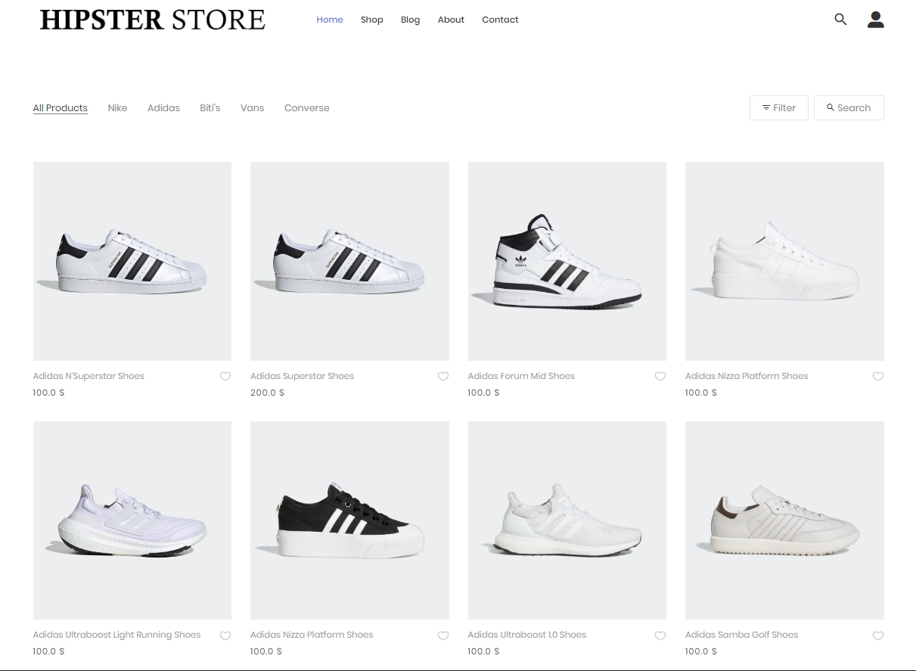

Step 1 : click Button Shop in navbar header

## 8. Search products

*Step 1:*

Click to the icon 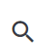

*Step 2:*

Input the product you want to search 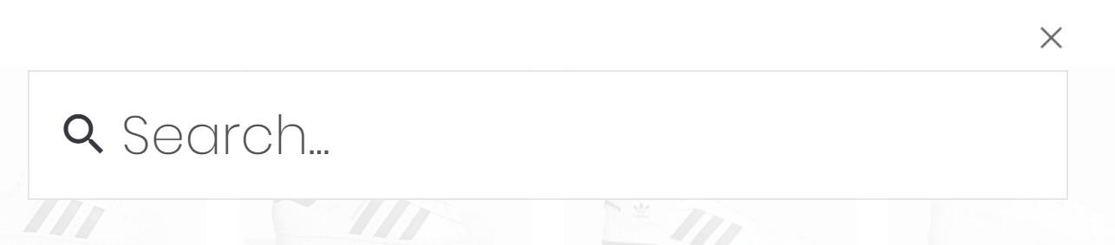

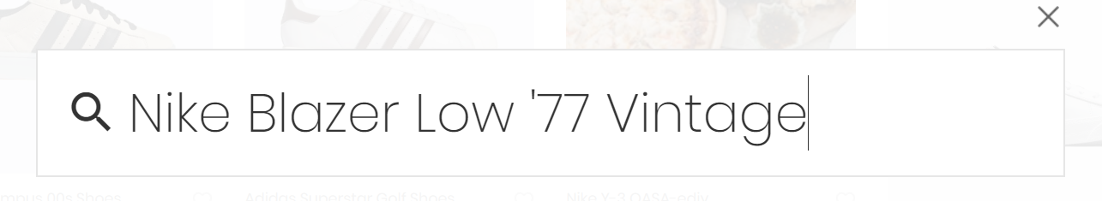

Step 3:

Enter from the keyboard, screen display:   
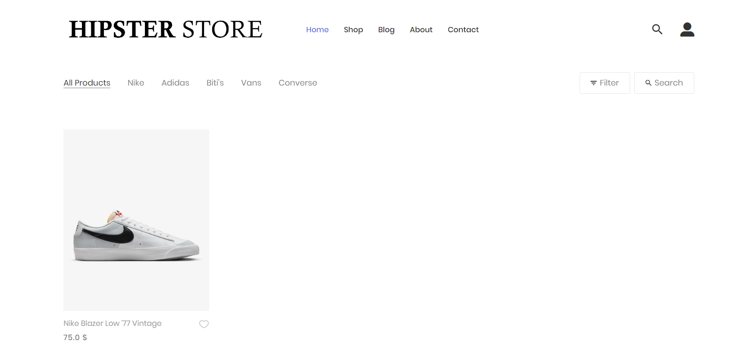

## 9. Read contents

*Step 1:*

Click to the Blog on the Navigation Bar **

*Step 2:*

Screen display  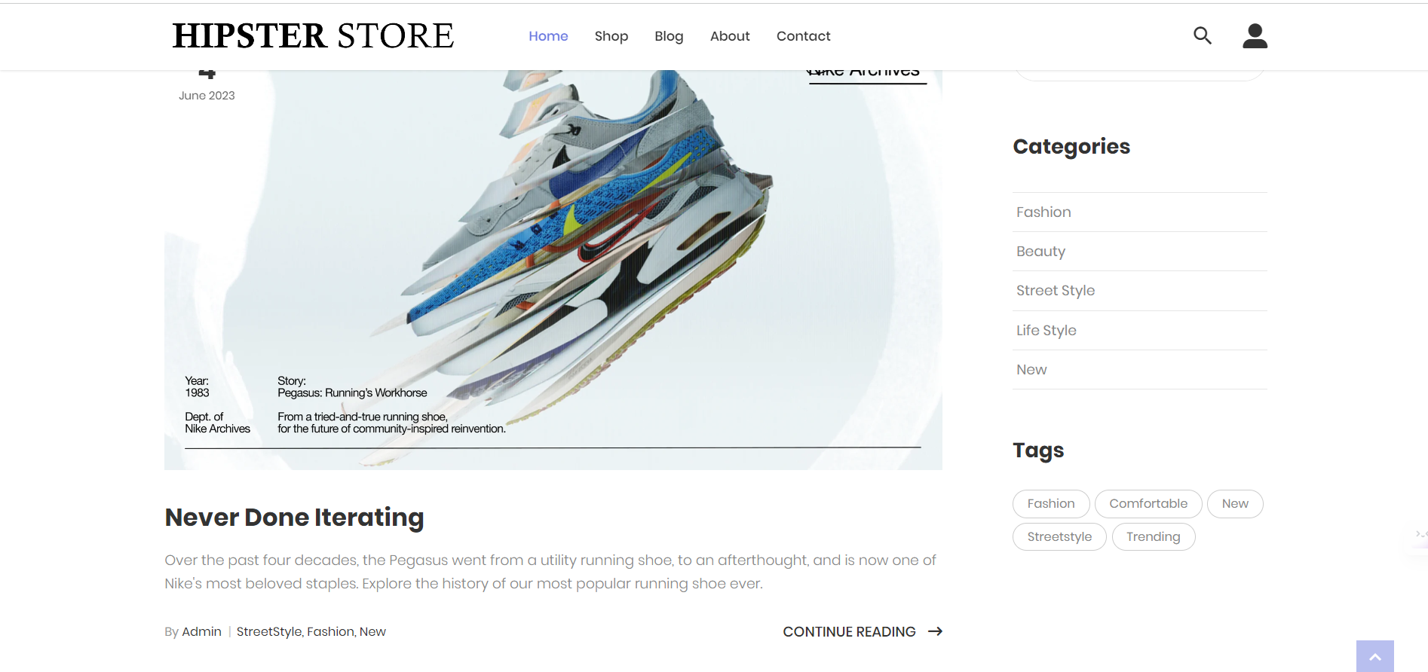

*Step 3:*

If you want to read the detailed contents, click to the link CONTINUE READING to read more

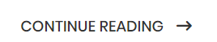

## 10. View personal information

*Step 1:*

You already have an account with each appropriate role and are logged into the system



*Step 2:* Click to 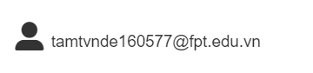

*Step 3:* Screen display  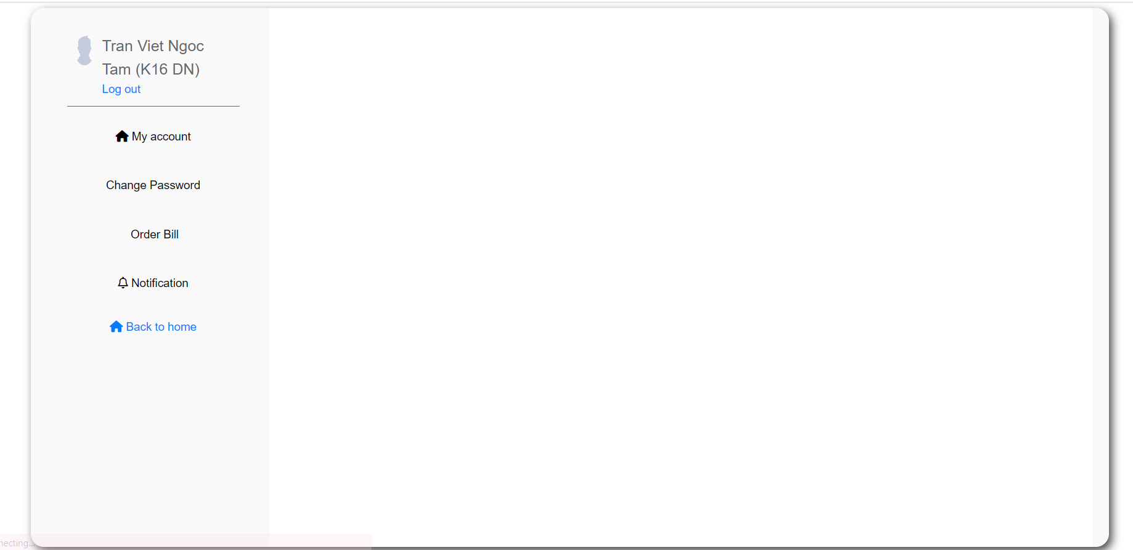

*Step 4:* Click to the button 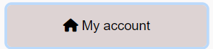

*Step 5:* Screen display your personal information  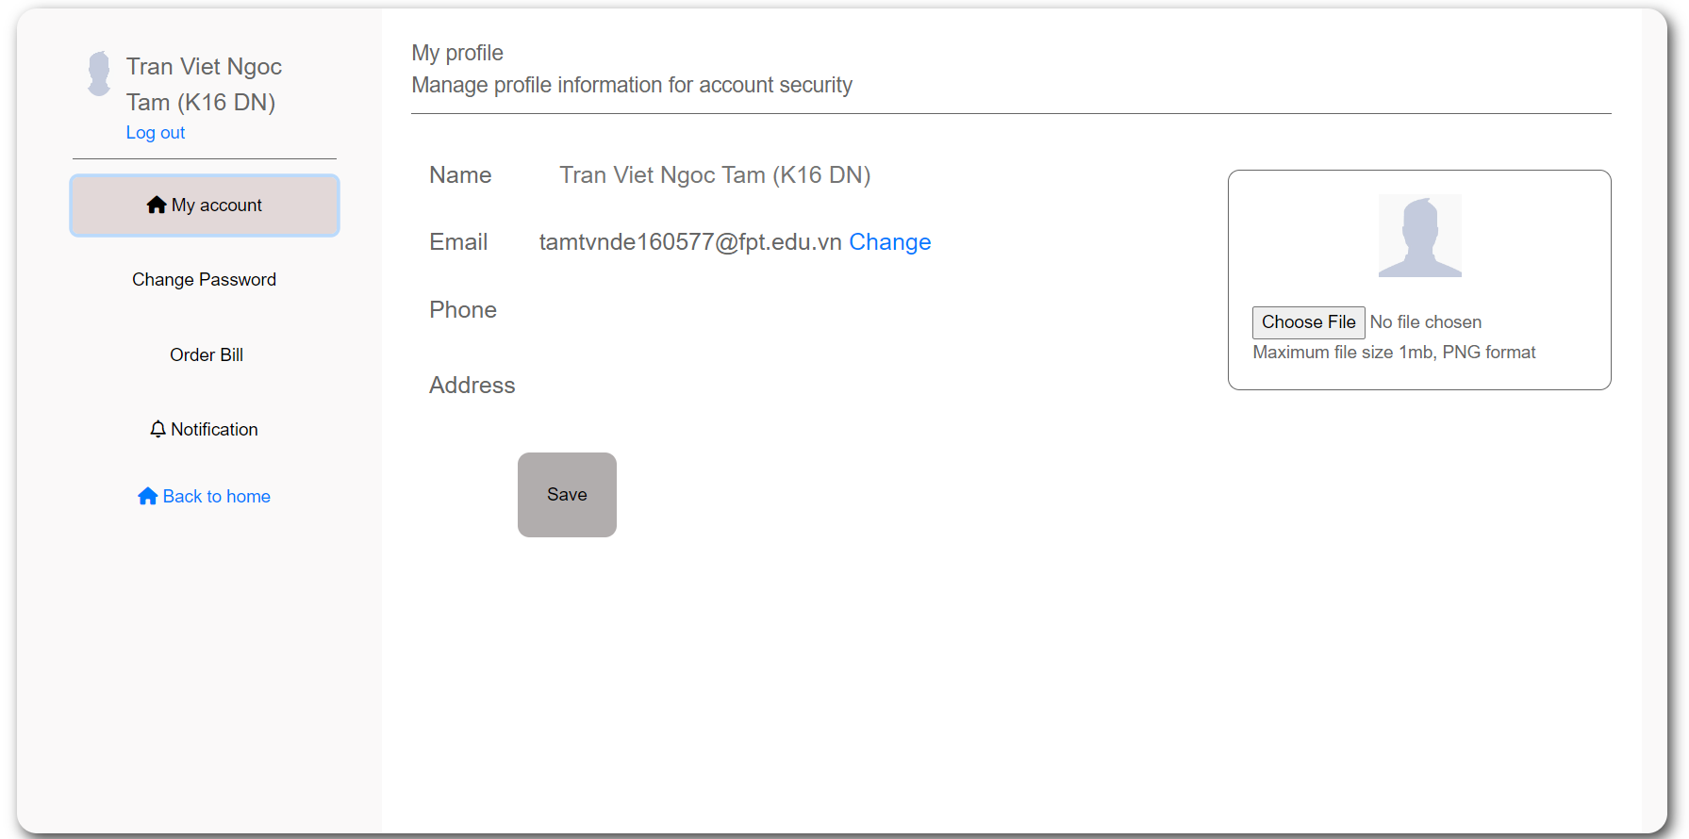

## 11. Update personal information

*Step 1:*

You already have an account with each appropriate role and are logged into the system



*Step 2:* Click to **

*Step 3:* Screen display  **

*Step 4:* Click to the button **

*Step 5:*

Screen display your personal information, also you can edit your personal information in here

**

*Step 6:*

Input the name, phone, address you want to change and upload the image if you want

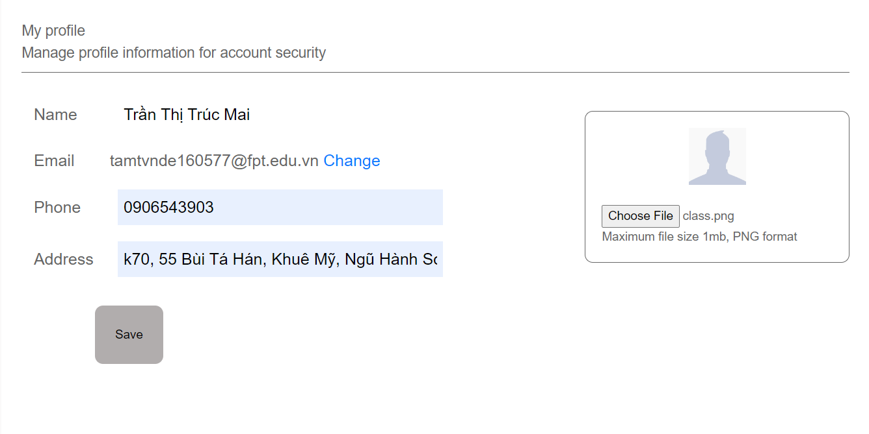

*Step 7:*

After you have edited the fields you want, click to button 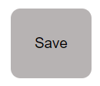and the new information will be updated.

## 12. Purchase

*Step 1:*

Click on any product you want to buy

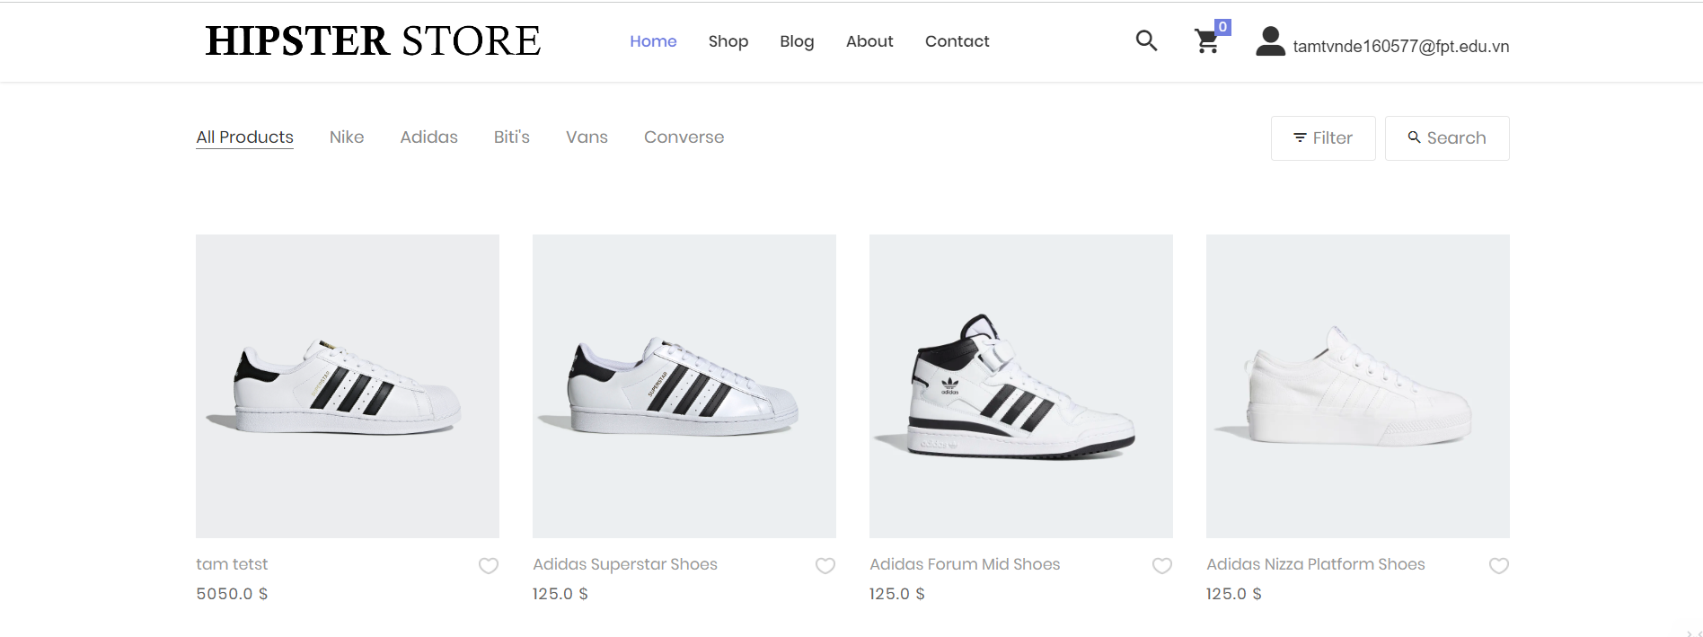

*Step 2:*

Screen display your choice, choose size and quantity you want

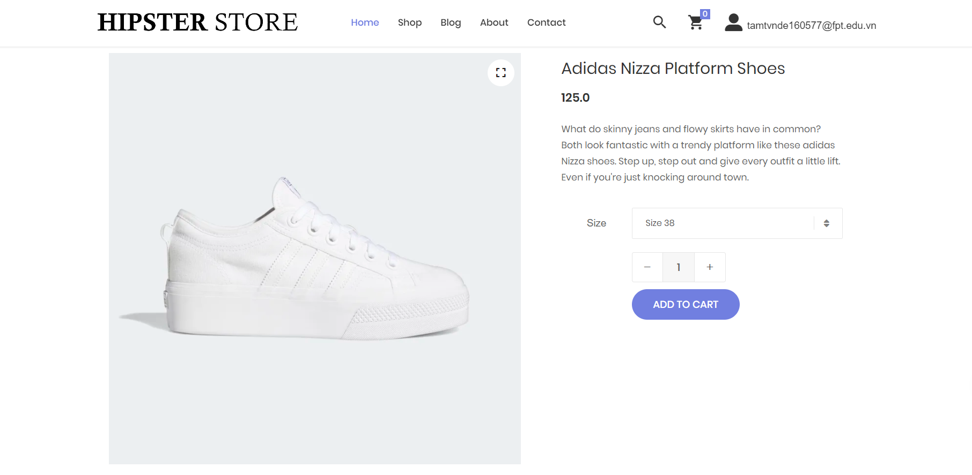

*Step 3:* Click on the button 

*Step 4:* After add to card, click to the icon 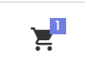in the Navigation Bar to checkout

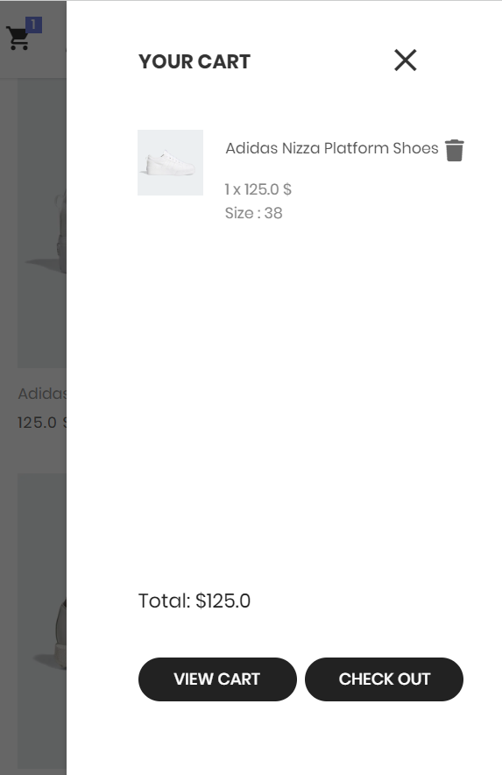

*Step 4:* Click to the button 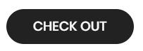to start the payment process

*Step 5:* Screen display form to fill in some require field before checkout 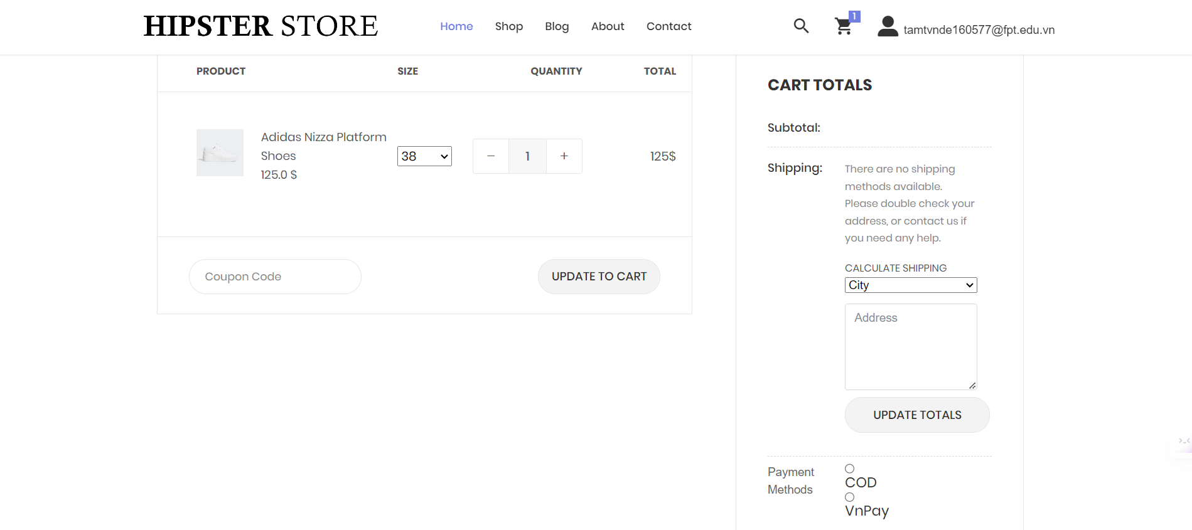

**

*Step 6:*

Click at least one product to purchase

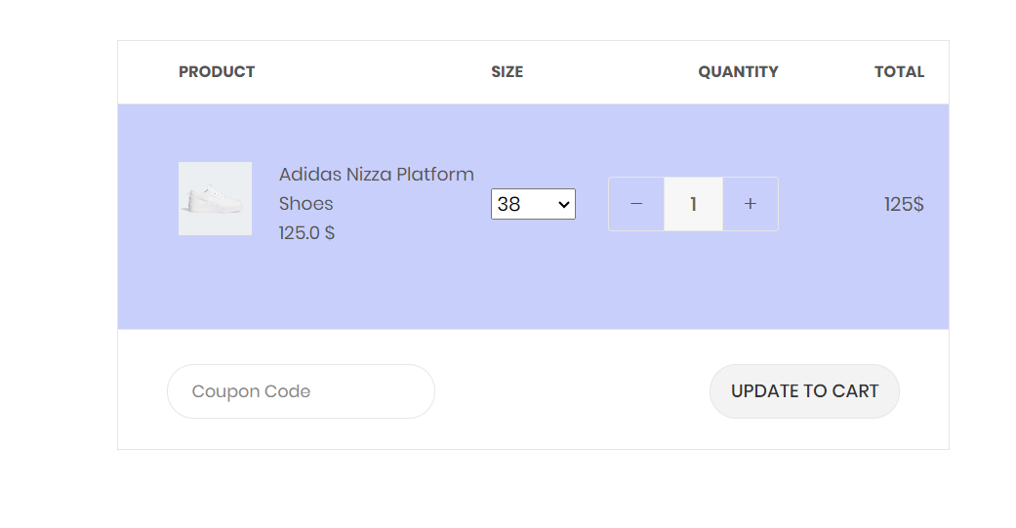

*Step 7:* Fill required fields  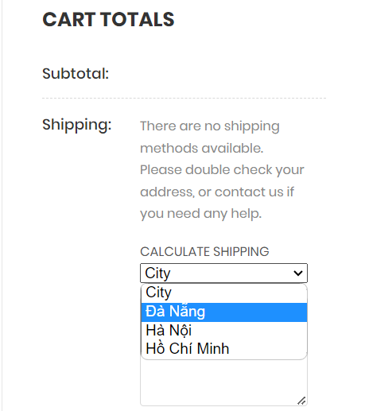

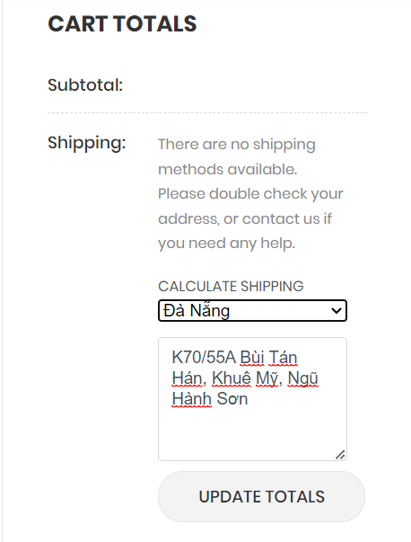

*Step 8:*

After choosing the address, click to the button 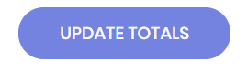to see how much you have to pay for the product after adding the shipping

*Step 9:*

Choosing the payment method you want

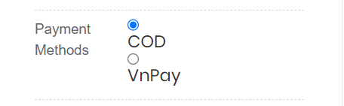

If you choose the VnPay method, the system will move you to another page to fill in the form of bank to support the payment process.

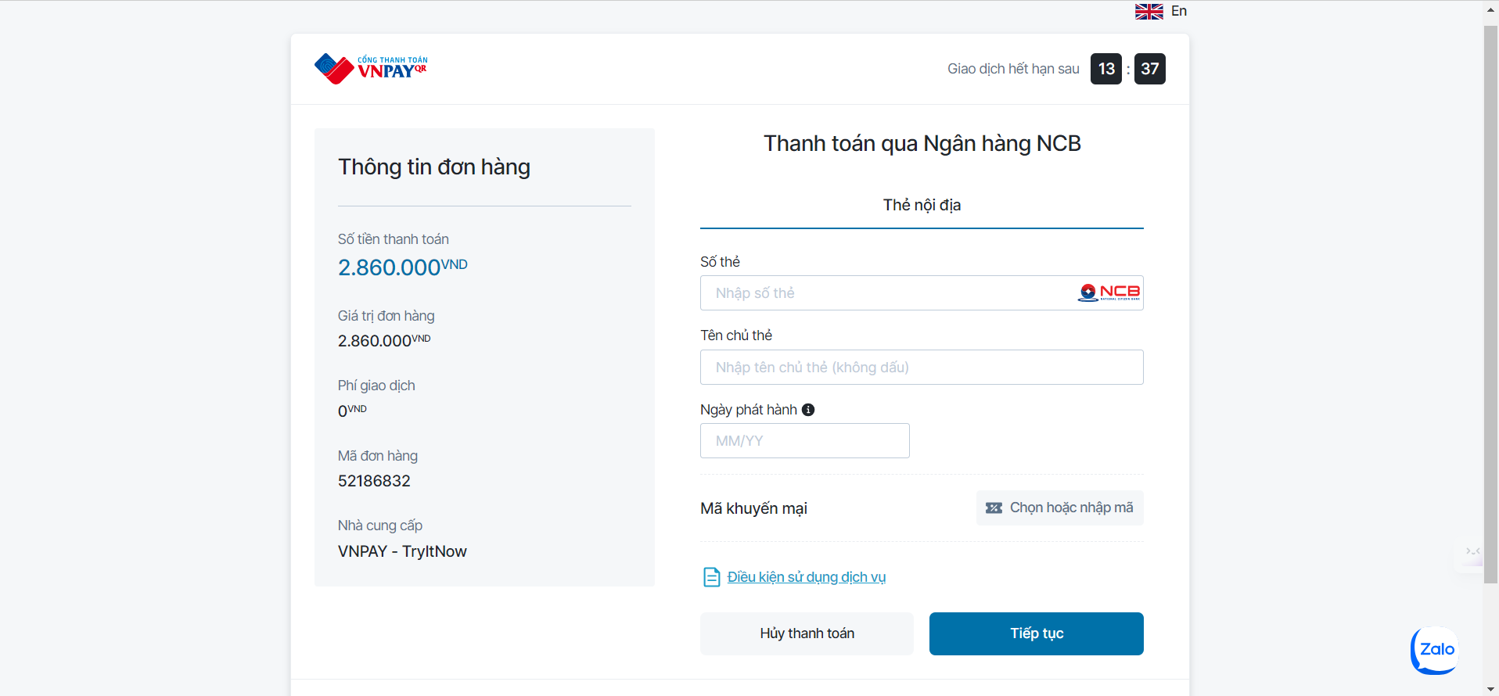

After fill in enough required information, click to the button to return the payment process

*Step 10:* Click to the buttonto finish the payment process

## 13. Choose a payment method

*Step 1:* Choosing the method you want

* If you choose COD (Cash on delivery), you will pay in cash to the shipper after receiving the goods



* If you choose VnPay method, the system you move you to another page to fill in the form of bank to support the payment process.



After fill in enough required information, click to the button to return the payment process

## 14. CRUD items in cart

This is a function that allows the user to edit the shopping cart in the store.

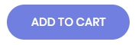

* Step 1: Click on the icon to add the product to the cart.

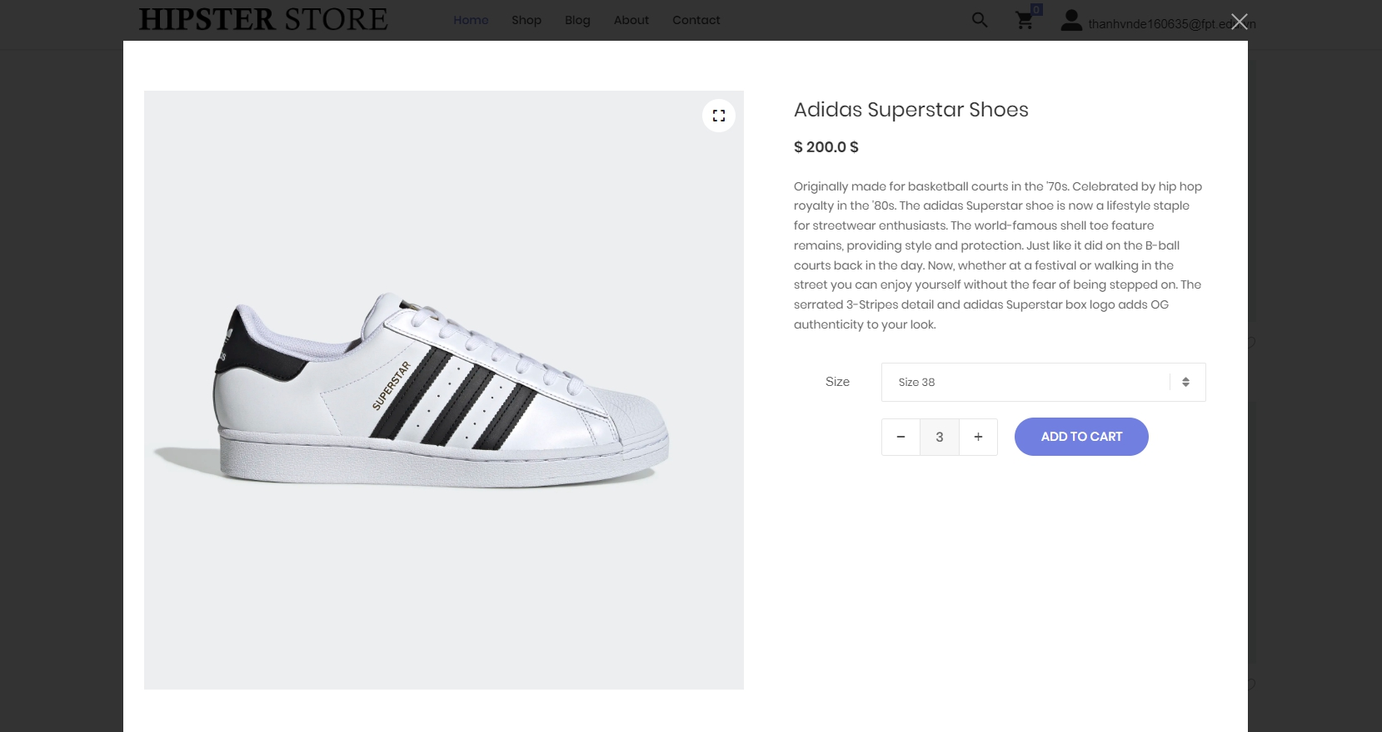

* Step 2: Click on icon to remove the product from the cart

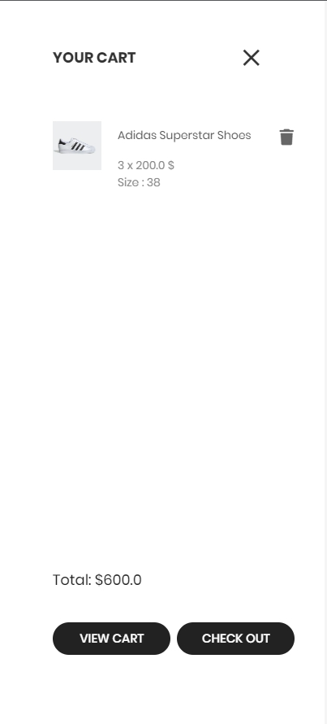

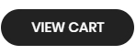

* Step 3: Click on icon to view cart details



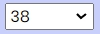

* Step 3: Click on icon to edit the product size

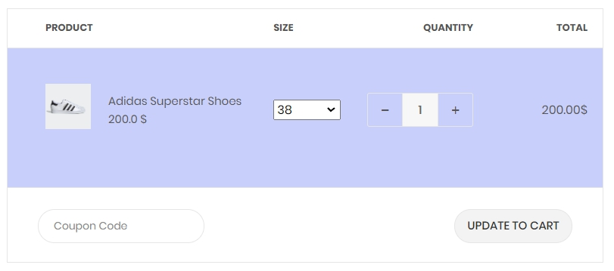

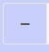

* Step 4: Click on icon to reduce the number of products.



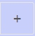

* Step 5: Click on icon to add the number of products.



## 15. View purchase history

This is a function that allows users to view purchase history.



* Step 1: Click on icon to go to the profile page

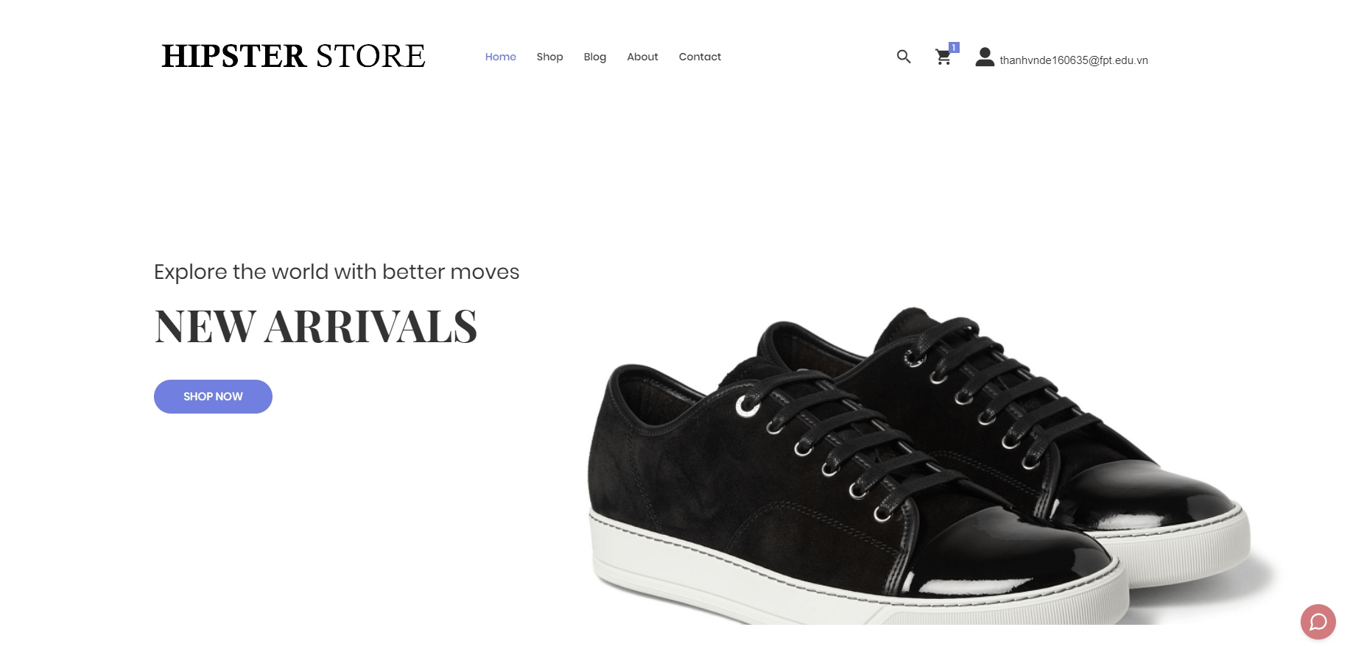

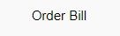

* Step 2: Click on button to view purchase history

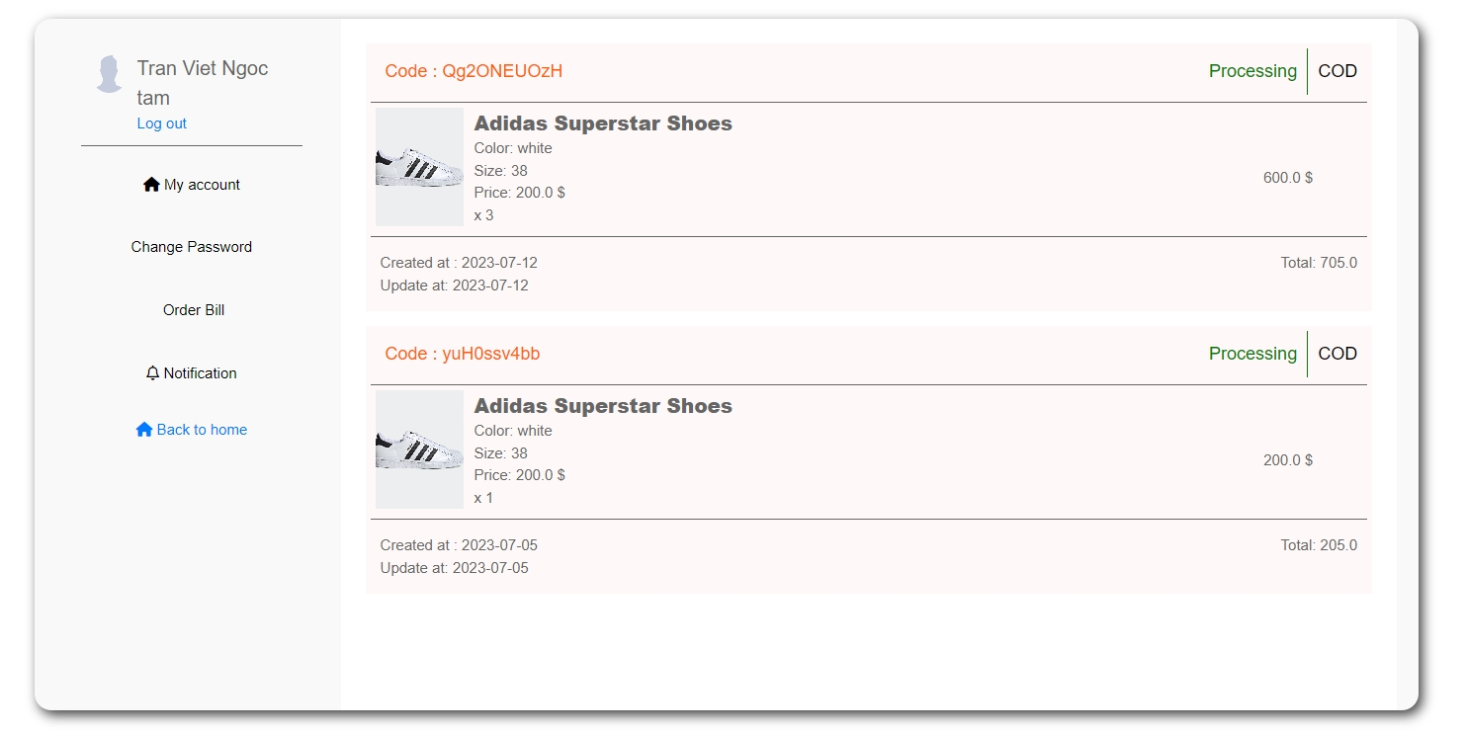

## 16. Track Order

This is a function that allows users to view order status.

* Step 1: Click on icon to go to the profile page





* Step 2: Click on button to view purchase history



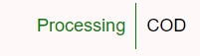

* Step 3: Check order status on status bar



## 17. View contact information

This is a function that allows users to view the store's contact information.

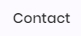

* Step 1: Click on button to see the store's contact information



* Step 2: View store contact information

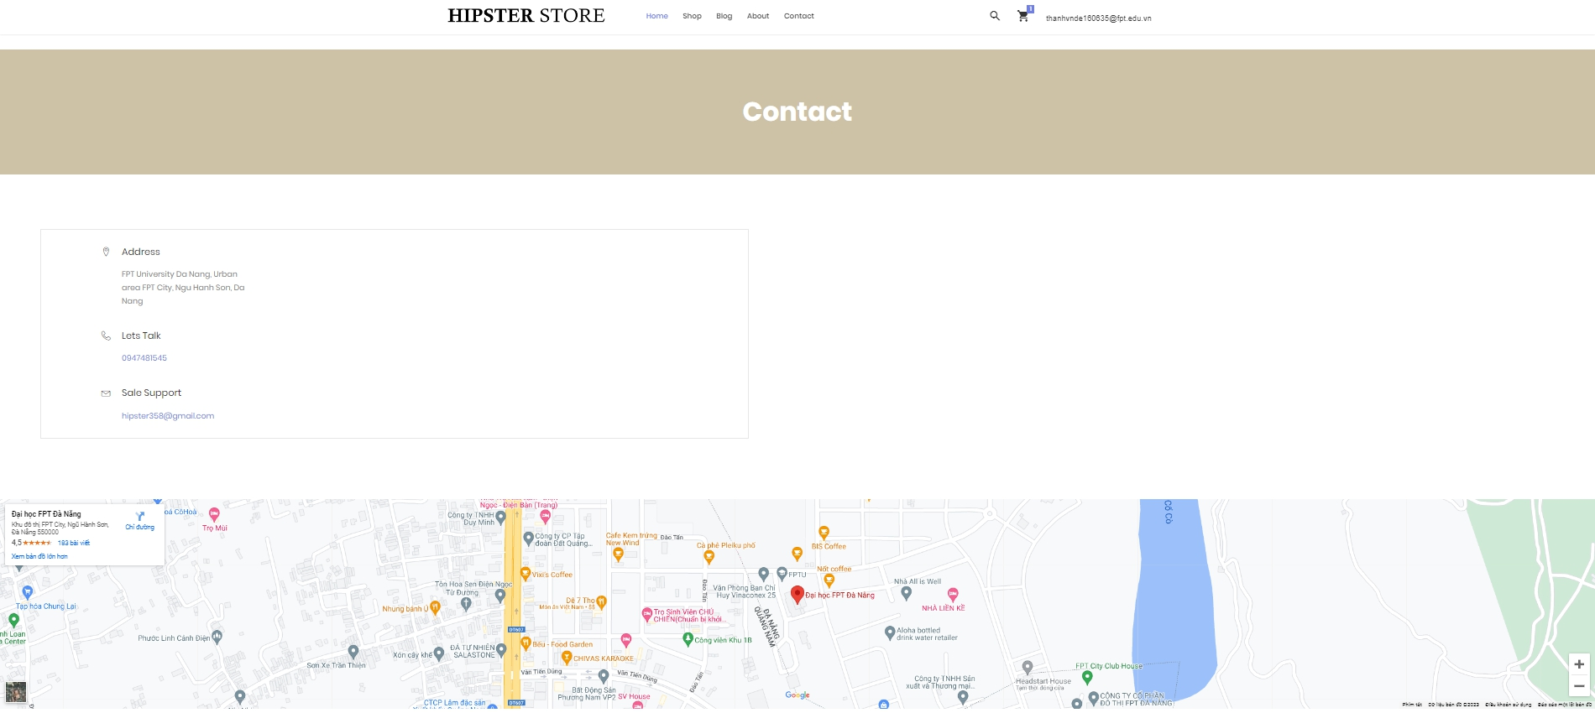

## 18. Chat with the shop

This is a function that allows users to chat with store staff with questions or report bugs.



* Step 1: Click on icon to open the chat box window



* Step 2: Select questions and requests in the chat box

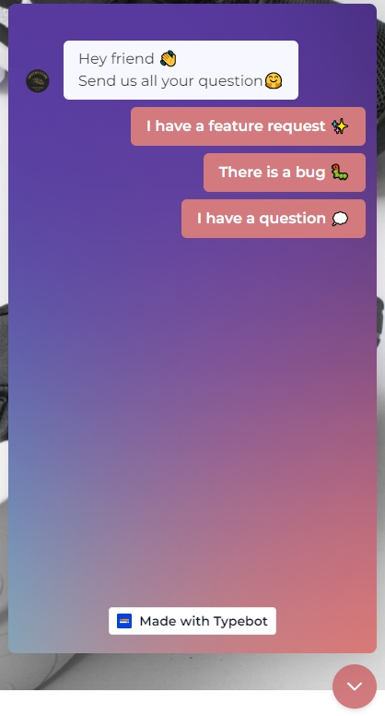

## 19.CRUD Content

This is a function that allows Content Creator to edit the content in the store.

* Step 1:Sign in with your Content Creator account to access the Content management page

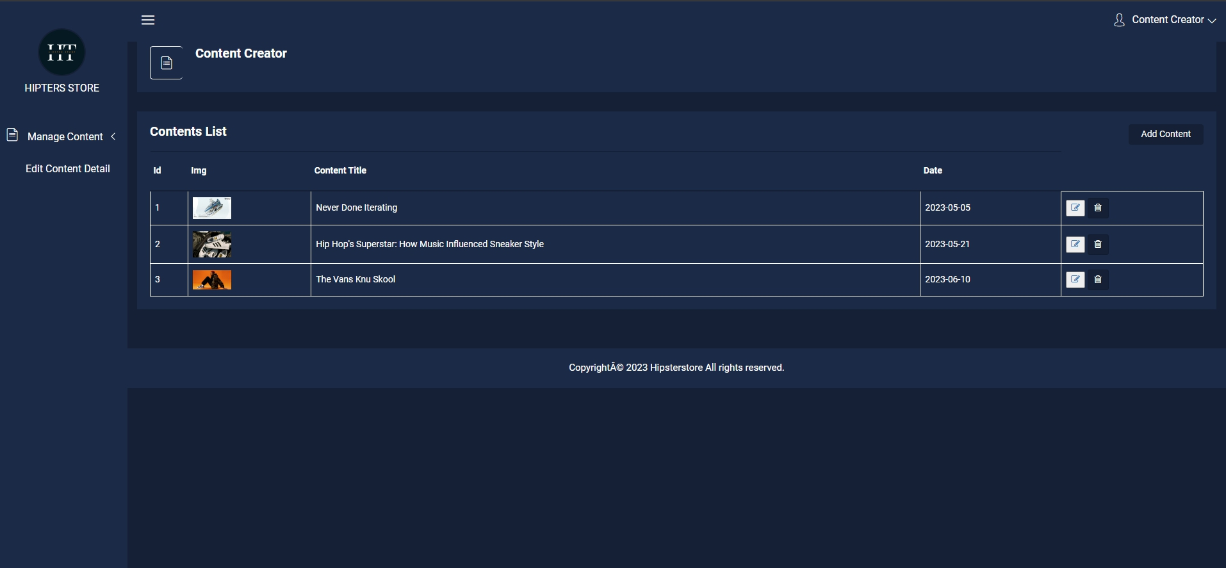

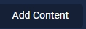

* Step 2: Click button to go to the Add New Content page

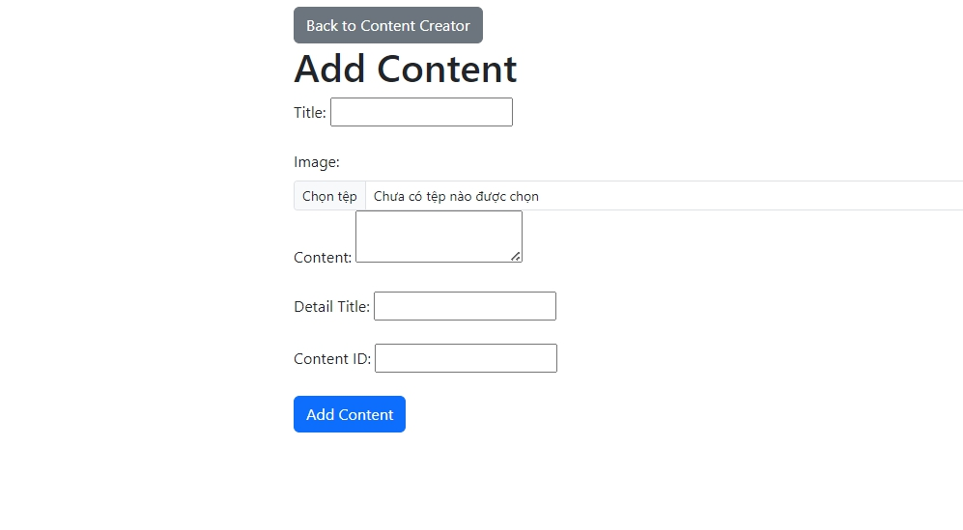



* Step 3: Enter the data for the new content and click button to save





* Step 4: Click icon to go to the edit content page





* Step 5: Enter the edit data for the content and click button to save

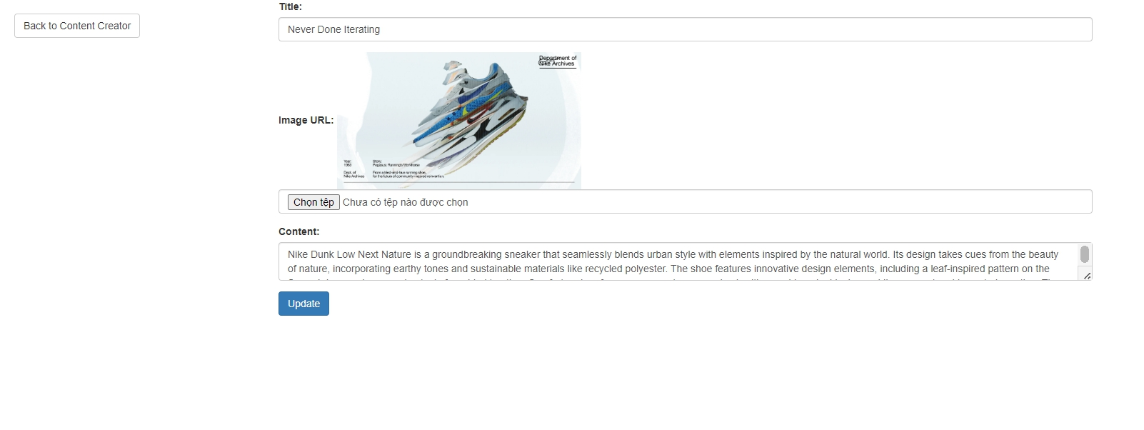



* Step 6: Click icon to delete the content



## 20. Confirm order:

This function confirms the order want to buy

Step 1: Add the product you want to pay for in the cart



Step 2: Full information about the order

**

**

Step 3: Once you have filled in all the information correctly, click the button  to confirm the order

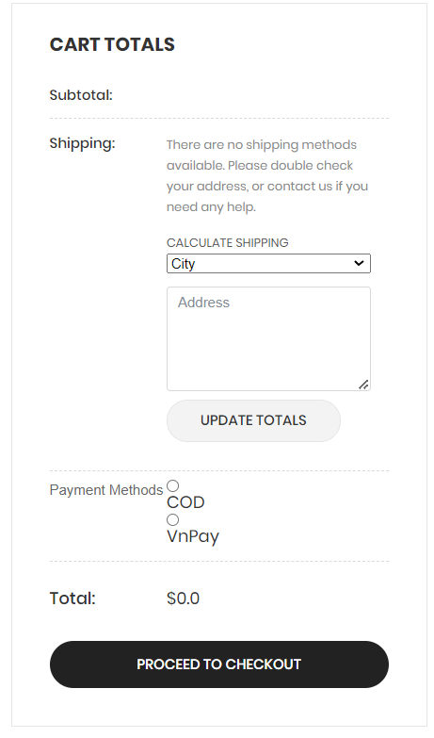

## 21. View order details

This function to view order details have been placed successfully

Step 1: After successfully placing an order, the user clicks the Home button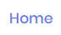 to return to the homepage



Step 2: Continue to click the My Profile 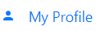button in the user's information button

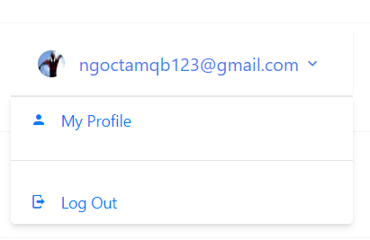

Step 3: At the user's information page continue to click the Notification button 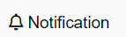 then the user's order status will be displayed

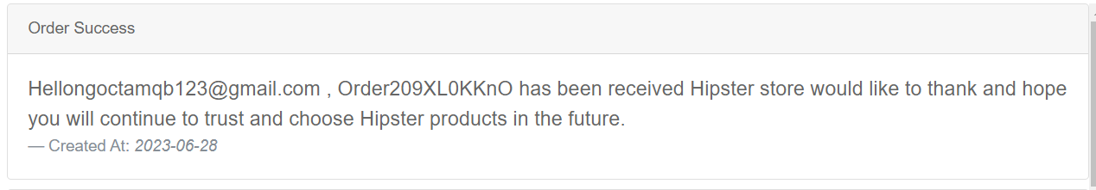

## 22. Confirm delivery

Step 1: In Manage order in transit , click button to confirm delivery

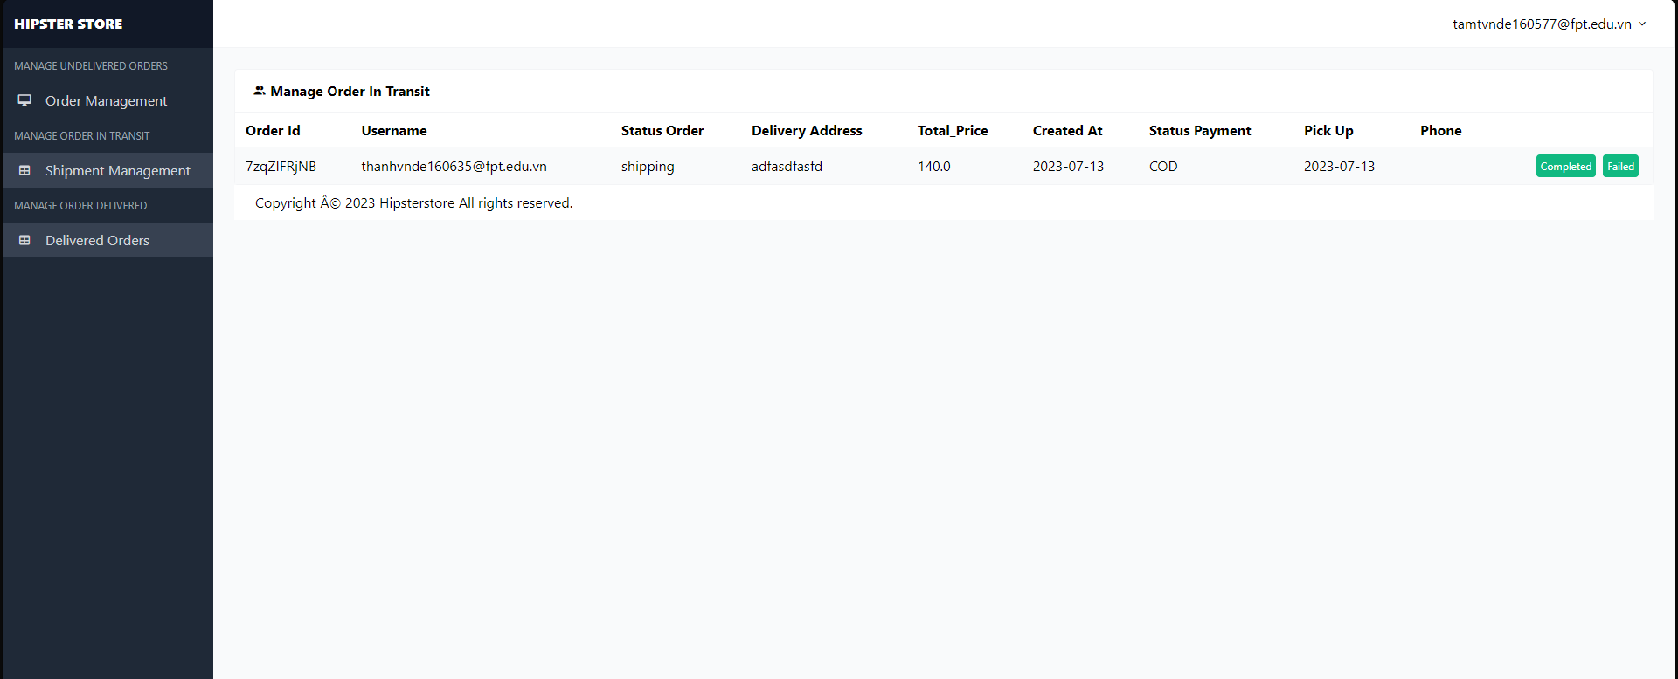

## 23. Check failed delivery

Step 1 : In manage order in transits , click button 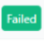 to failed delivery



step 2: fill the reason for ship failed in th popup.

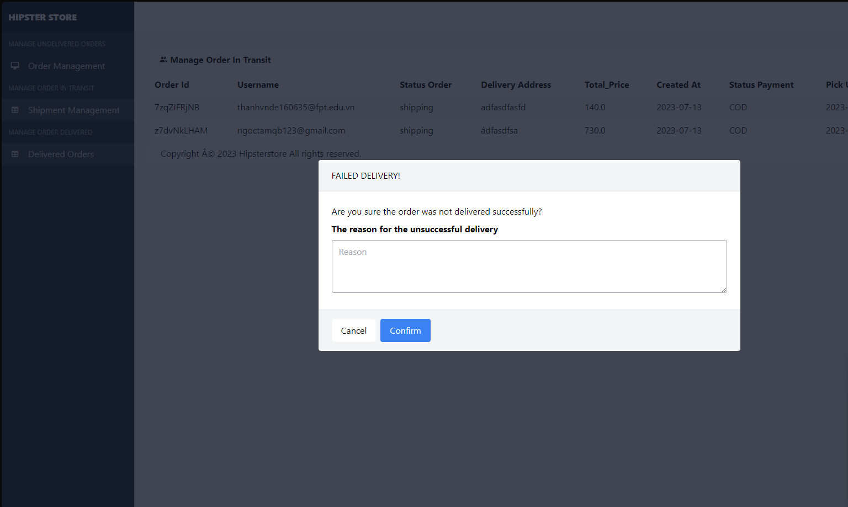

## 24. CRUD products

Step 1: In Manage Product click the button 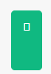 to add products

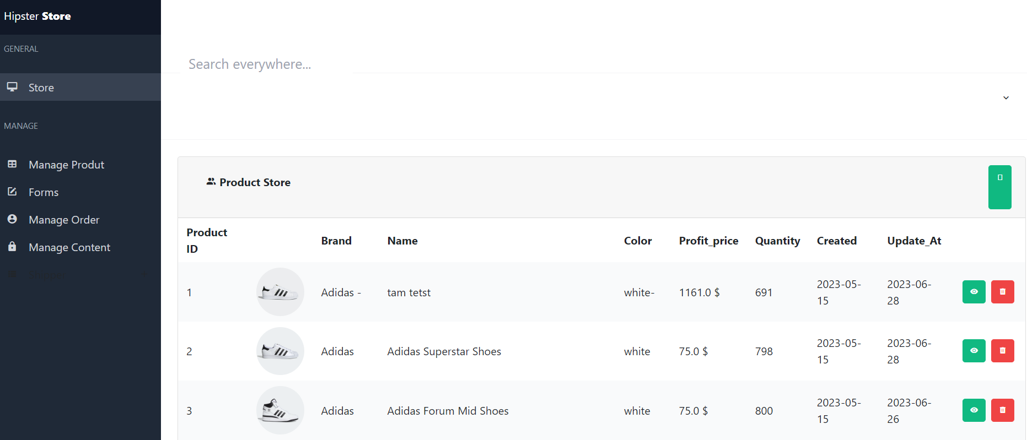

Step 2: Fill in the information of the product you want to add to the shop, then click the Confirm button 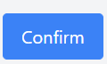 to confirm

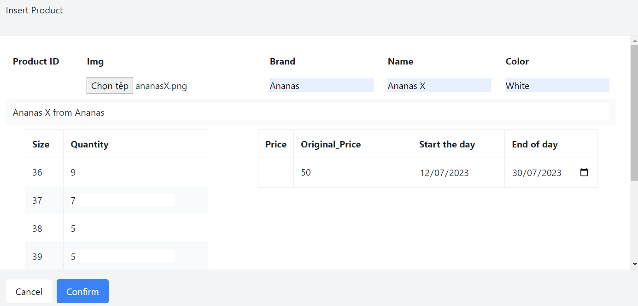

Step 3: In Manage Product click the button 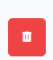 to delete products, the product page you want to delete will be displayed. then click the Confirm button 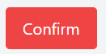to confirm delete products.

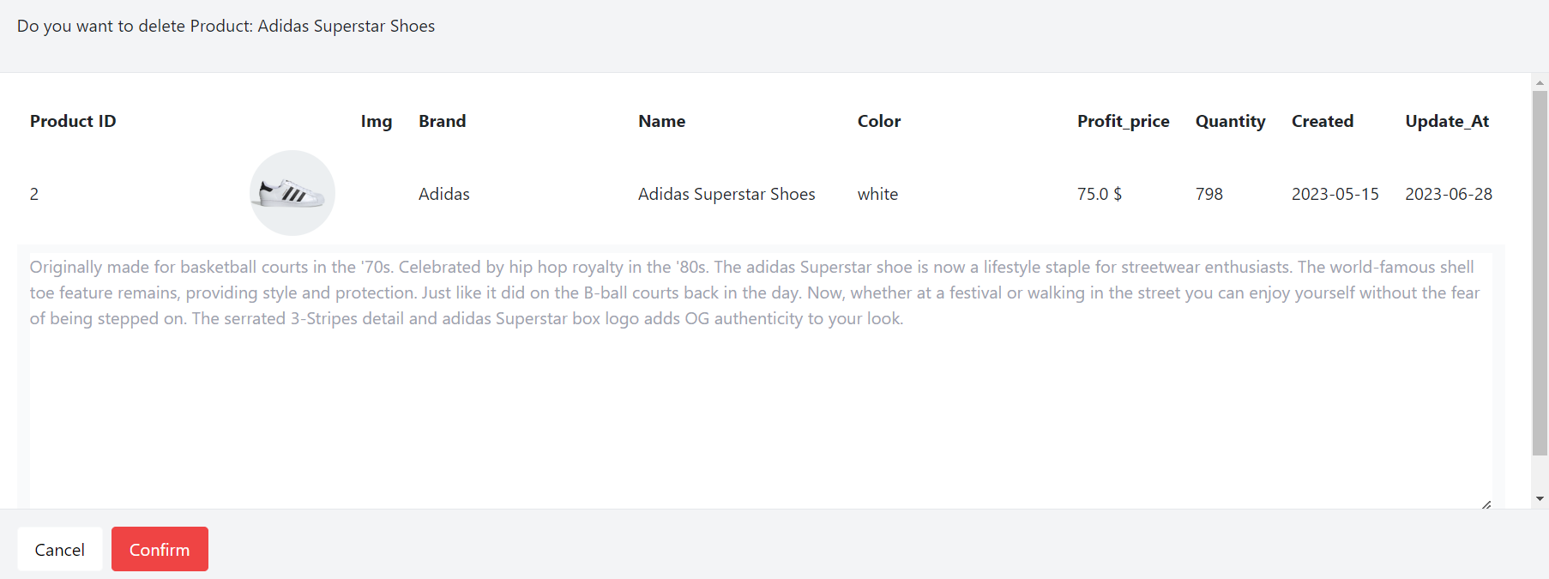

Step 4: User wants to edit product details click on the button , detail edit page will be displayed



Step 5: At the View Details page, users will fill in the information they want to edit the product, then click the Confirm button  to confirm

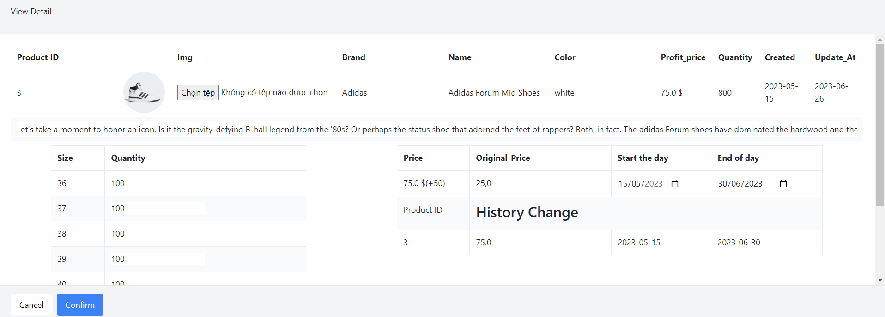

## 25. View order status

Step 1: Click on the user's info button 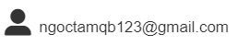

Step 2: Click the Order Bill button 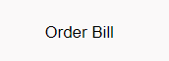 to view the order status of the order



## 26. View sale history

step 1 : Click Manage order in Amdin Page .

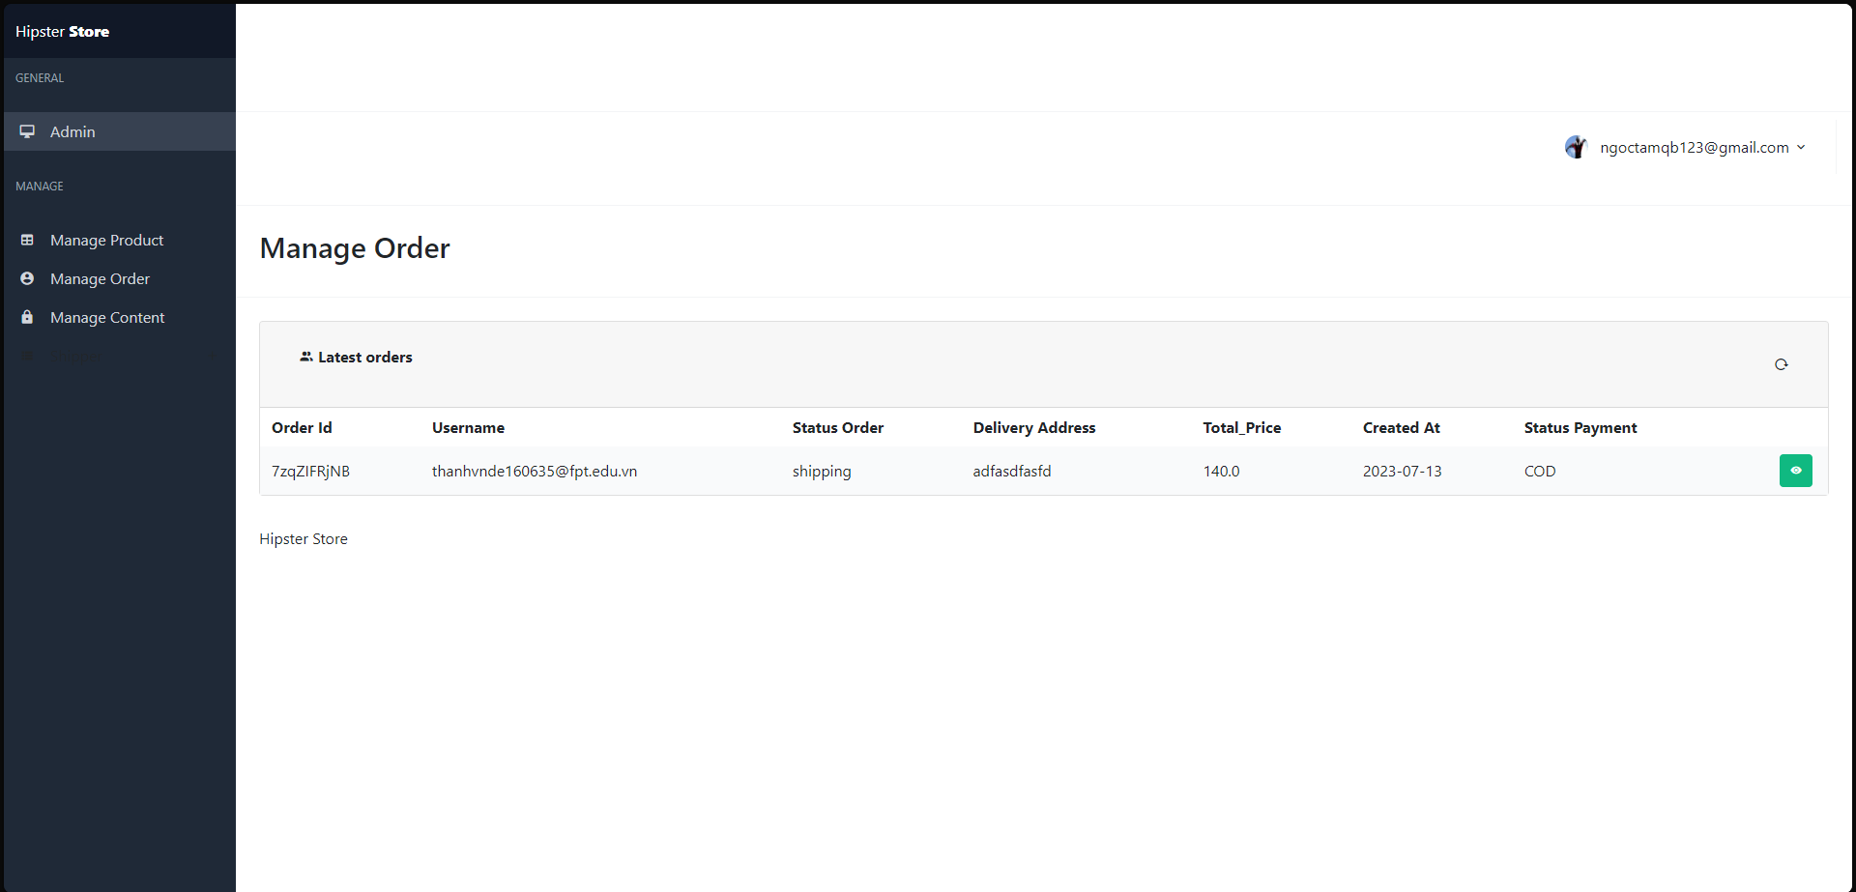

step 2 : Click button 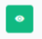 to view detail

## 27. View the revenue

step 1 : Login by account admin

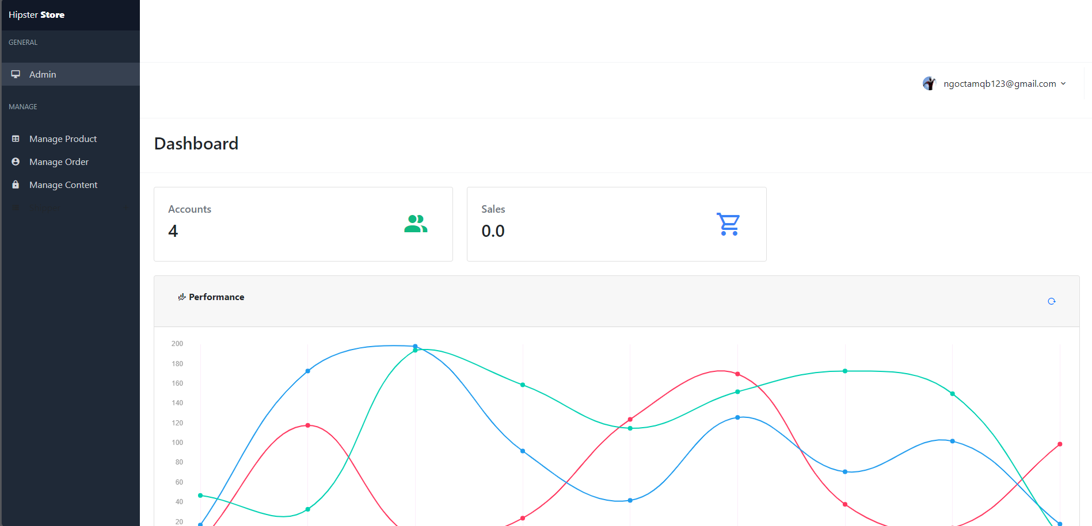

## 28. View detailed order history

tep 1: Click on the user's info button 

Step 2: Click the Order Bill button  to view the detailed order history of the ordered products



## 29. CRUD employees

Step 1: Click the Manage User button, the accounts registered at the shop will be displayed

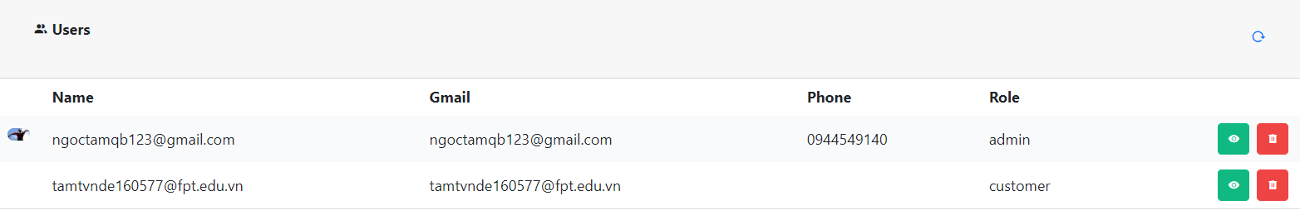

Step 2: Click button to view user details to update the product. Then Update User Roles. Continue pressing the Confirm button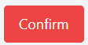 to confirm the User Update role

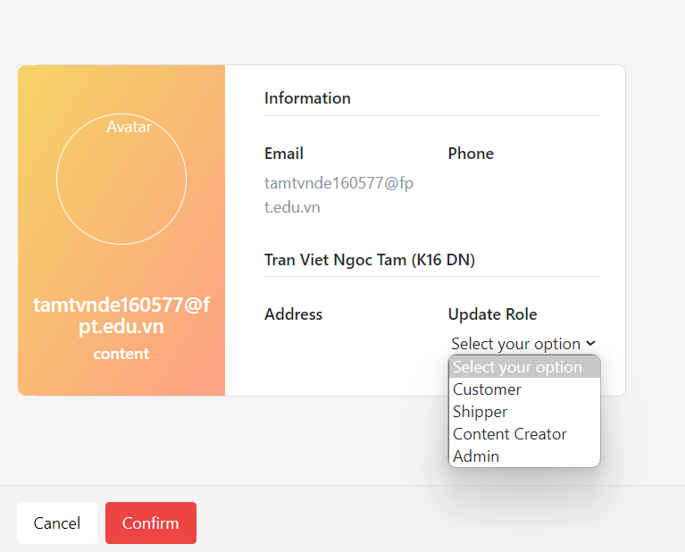

Step 3:Click the Manage User button, Click the button delete employees users  at the shop's website



Step 4: Confirm Delete page will be displayed, click Confirm button 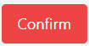 to confirm delete

